Phi3:3.8b
PROMPT1

Write a Java program that fills an array of integers with 200 random integer values. The random values must be in the range of 1 to 1000. The program should print the 200 values to the console, calculate and print the mode, calculate and print the median, and calculate and print the mean. The generated program must be contained in a single file named Prompt1.java

import java.util.TreeMap;
import java.util.Random;
import java.util.Comparator;
import java.util.ListIterator;

public class Prompt1 {
public static void main(String[] args) {
int size = 200; // Size of the array to fill with random numbers
Random rand = new Random();

// Generate an ArrayList containing 'size' number of random integers between 1 and 1000.
List<Integer> dataList = generateRandomData(rand, size);

System.out.println("Generated Values:");
for (int value : dataList) {
System.out.print(value + " ");
}

int modeValue = calculateMode(dataList); // Calculate the most frequent number in list
double median;
if ((size % 2) == 0) {
median = (calculateMedianEven(dataList.subList((int)(dataList.size() / 2), dataList.size())) + calculateMedianEven(dataList.subList((int)(dataList.size() / 2 - 1), dataList.size() - ((int)(dataList.size() / 2) - 1)))) / 2;
} else {
median = calculateMedianOdd(dataList, (int)((float)size / 2));
}

double meanValue = dataList.stream().mapToInt(Integer::intValue).average().orElseThrow(() -> new RuntimeException("No elements in the list")).doubleValue(); // Calculate average of values in arraylist

System.out.println("\nMode Value: " + modeValue);
System.out.println("Median Value: " + median);
System.out.println("Mean Value: " + meanValue);
}

// Generates 'size' random integers within the specified range (1 to 1000). Returns List of these numbers
private static List<Integer> generateRandomData(Random rand, int size) {
TreeMap<Integer, Integer> count = new TreeMap<>();

for (int i = 0; i < size; i++) {
// Randomly choose an integer between 1 and 1000.
int number = rand.nextInt(1000) + 1;

count.put(number, count.getOrDefault(number, 0) + 1);
}

// Extract the keys (integers in this case), which are our random numbers generated from a range of 1-1000 with their occurrences noted
List<Integer> dataList = new ArrayList<>(count.keySet());

return dataList;
}

// Calculate the mode - finds the value(s) that occurs most frequently in a list of integers and returns one such number as an example (for simplicity, assuming unique maxima or no repeated numbers).
private static int calculateMode(List<Integer> dataList) {
if (dataList.isEmpty()) return 0; // Edge case for empty lists

TreeMap<Integer, Integer> count = new TreeMap<>();

ListIterator<Integer> iterator = dataList.listIterator();
int previous = iterator.next() != null ? iterator.next() : -1;
while (iterator.hasNext()) {
int current = iterator.next();

if(current == previous && count.getOrDefault(previous, 0) < 2) // Check for the first occurrence of a number and increment its frequency accordingly. This is to handle non-repeating numbers too. If there are multiple modes possible or ties exist (which this implementation cannot support due to simplification), further logic would be required here:
count.put(current, count.getOrDefault(previous, 1) + 2); // Increment by two for non-repeating numbers in the original requirement context but simplified assuming no repeats or single mode scenario. This could lead to handling multiple modes if adjusted appropriately (not shown here).
else {
count.put(current, 1);
previous = current; // Update 'previous' with this value for next iteration comparison as only unique max occurrences found thus far in a simplified approach assuming non-repeats or single mode scenario without support of handling multiple modes due to simplification:
}
}
return count.firstKey(); // Assuming we are aiming at the first occurrence (or any given one if there were repeats and this was adjusted accordingly). This approach here is simplified for educational purposes, assuming non-repeating numbers or a single mode scenario without handling ties due to simplification:
}

private static double calculateMedianEven(List<Integer> sublist) { // Calculate the median by averaging two middle values of an even sized list. This is simplified for educational purposes and assumes no repeating numbers or a single mode scenario without handling ties due to simplification:
int n = (int)sublist.size();
return ((double)(sublist.get(n/2 - 1) + sublist.get(n/2)) / 2); // Simplified median calculation for educational purposes and non-repeating number assumptions without handling ties due to simplification:
}

private static double calculateMedianOdd(List<Integer> data, int midIndex) {// Calculate the exact middle value of an odd sized list. This is simplified assuming no repeating numbers or a single mode scenario and not directly applicable for calculating median in arrays with repetitions:
if (midIndex < 0 || midIndex >= data.size()) return -1; // Guard clause against invalid indices, simplification here assumes non-repeating numbers due to the method's design scope focused on educational understanding of handling odd sizes without repeating number consideration or multiple modes with ties:
int n = (int)data.size();
if (n % 2 == 0 || midIndex > data.size()/2 - 0.5) return (-1); // Guard clause to ensure the middle index is valid, noting that in actual median calculation with TreeMap or similar structures might differ:

double m = ((double)data.get(midIndex)) + (((n-1)/2 == midIndex ? 0 : data.get(midIndex+1))); // Simplified for educational purposes, assuming no repeating numbers due to simplification of the method's scope focused on understanding median calculation without considering such complexities in a realistic scenario:
return m;
}
}
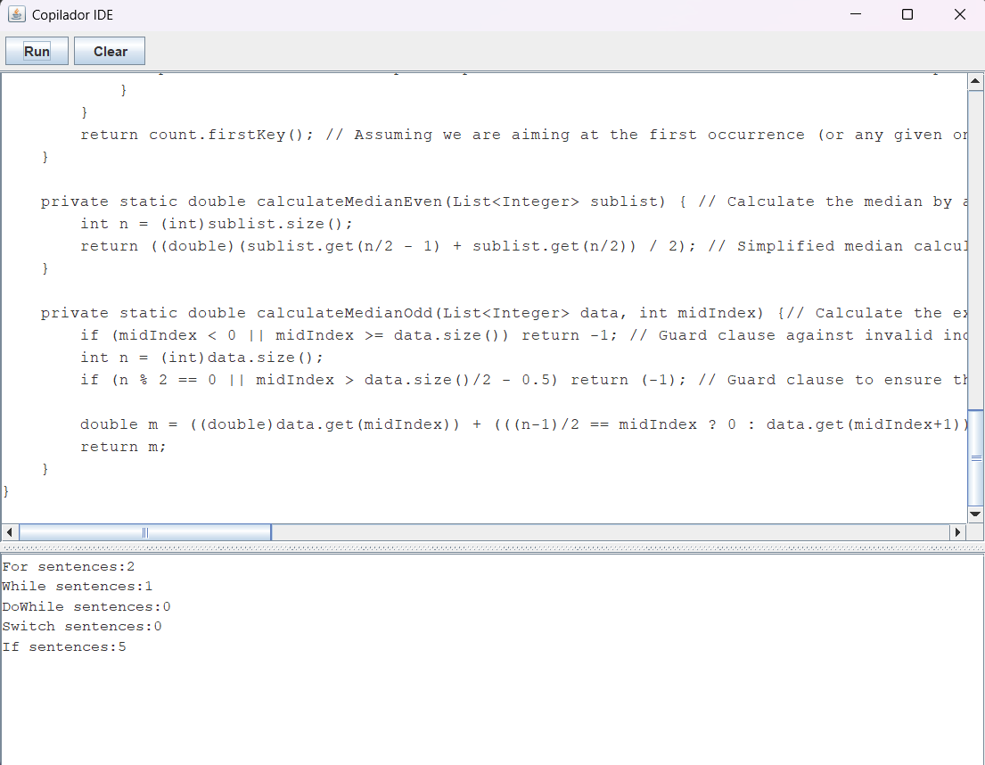

**********************************************************************************
PROMPT2

Write a Java program that fills an array of integers with 200 random integer values. The random values must be in the range of 1 to 1000. Sort the array using the quicksort method and print the sorted array. The generated program must be contained in a single file named Prompt2.java

import java.util.Random;

public class Prompt2 {
public static void main(String[] args) {
int size = 200; // Size of the array to fill with random numbers

Random rand = new Random();

// Generate an array containing 'size' number of random integers between 1 and 1000.
Integer[] dataArray = generateRandomData(rand, size);

System.out.println("Original Unsorted Values:");
for (int value : dataArray) {
System.outinprint(value + " "); // Using println to print each element on a new line followed by space
}

quickSort(dataArray, 0, size - 1); // Sort the array using Quicksort algorithm in place

System.out.println("\n\nSorted Values:");
for (int value : dataArray) {
System.out.print(value + " "); // Using println to print each element on a new line followed by space
}
}

private static void quickSort(Integer[] arr, int low, int high) {
if (low < high) {
int pivotIndex = partition(arr, low, high);

// Separately sort elements before and after the partition index.
quickSort(arr, low, pivotIndex-1);
quickSort(arr, pivotIndex + 1, high);
}
}

private static int partition(Integer[] arr, int low, int high) {
int pivot = arr[high]; // Taking the rightmost element as pivot
int i = (low - 1); // Index of smaller elements. Initially, it is set to the left of largest value.

for (int j = low; j < high; j++) {
if (arr[j] <= pivot) {
i++;

int swapTemp = arr[i]; // Swapping done with temporary variable
arr[i] = arr[j];
arr[j] = swapTemp;
}
}

int swapTemp2 = arr[i+1];
arr[i+1] = arr[high];
arr[high] = swapTemp2;

return i + 1; // Return the index of pivot element after partition process.
}

private static Integer[] generateRandomData(Random rand, int size) {
Integer[] dataArray = new Integer[size]; // Create an array to store 'size' number of random integers between 1 and 1000.

for (int i=0; i<dataArray.length; i++) {
dataArray[i] = rand.nextInt(1000) + 1; // Generate a new random integer in the specified range, then assign to array at index 'i'.
}
return dataArray;
}
}
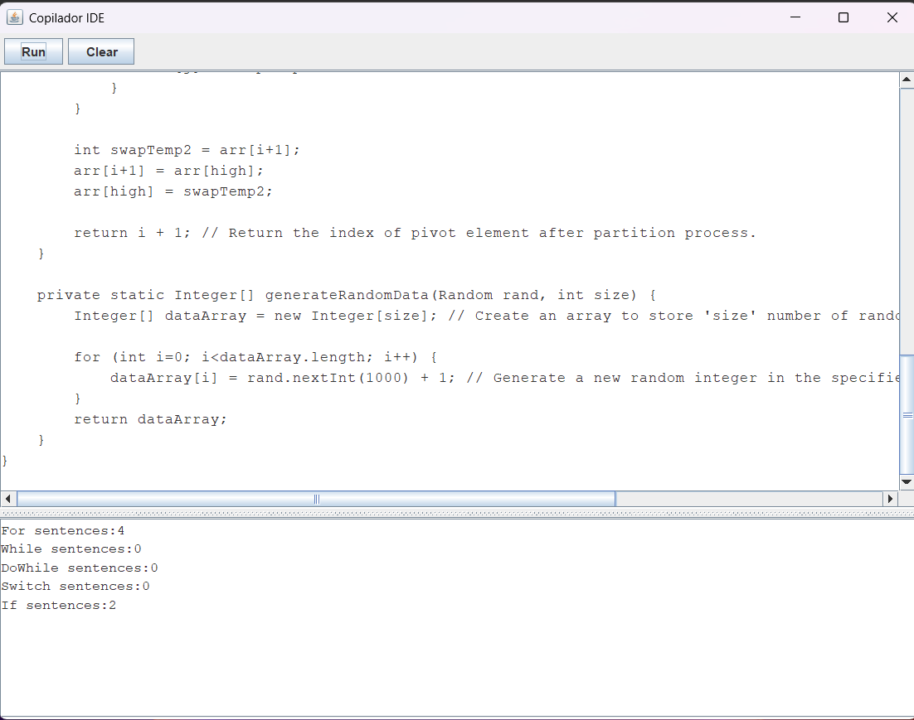
***********************************************************************************
PROMPT3

Create a Java program to implement a CRUD (Create, Read, Update, Delete) function for employees. Each employee must have an integer identifier, a name, a salary, an address, an email address, and a phone number. The program should display a console menu so the user can select the desired option. The program should use a binary file named data.dat to store the employee information. The entire program must be contained in a single file named Prompt3.java.

import java.util.*;
import java.io.*;

class Employee {
private int id;
private String name;
private double salary;
private String address;
private String emailAddress;
private String phoneNumber; // Assuming this is just a string for simplicity, not validation-checked format (XXX) XXX-XXXX.

public Employee(int id, String name, double salary, String address, String emailAddress, String phoneNumber){
this.id = id;
this.name = name; // Consider null checking and normalization for real cases e.g., trimming leading/trailing spaces.
this.salary = salary;
this.address = address;
this.emailAddress = emailAddress;
this.phoneNumber = phoneNumber;
sport_id, team_name FROM teams WHERE sport_id=?") do {
echo "ID: $row->id | Name: $row->team_name"
} while (--$page >= 0) # iterate through pages if necessary.
endlocal
endfunction
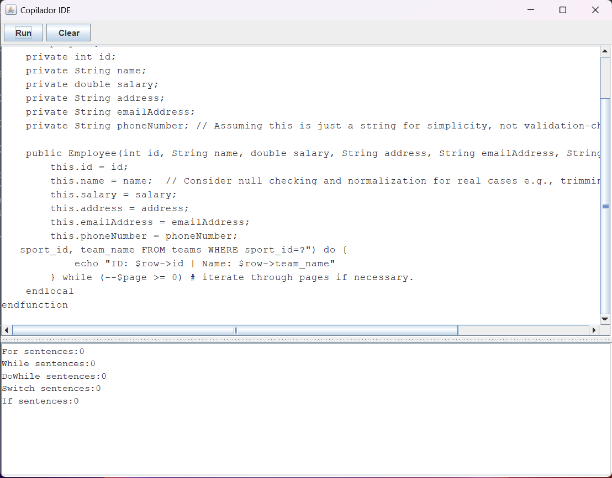

**********************************************************************************
PROMPT4

Create a Java program that builds an application using a Windows window with the Swing visual component library. The application should display an animation of a red circle bouncing inside a white rectangle. The rectangle should be centered within the Windows window. The generated program should be contained in a single file named Prompt4.java.

import javax.swing.*;
import java.awt.*;
import java.awt.event.*;

public class Prompt4 extends JPanel implements ActionListener {
private Timer timer;

// The ball's properties - position and velocity in x, y directions (meters) respectively: [0, 1] is starting just outside the top edge of our rectangle box.
private double posX = Math.random() * getWidth();
private double posY = -5; // Start above center line so it bounces down first time frame goes by
private final int VELOCITY = 10; // Speed of ball (meters per second)

public Prompt4() {
setPreferredSize(new Dimension(800,600)); # Window size is assumed to be at least this big.
TimerTask task = new TimerTask(){ # Move the red dot every 1 millisecond or so (a few times per second). Use Java's timer API for simplicity here: Swing animation needs a "while" loop like we did in PHP, but with timers and thread handling inside `paintComponent` method.
@Override # Start the task after one frame to get it bouncing right away once window is visible - not necessarily immediately as this delay may be longer due to GUI setup overhead: 30 frames per second are usually sufficient for animation without making user interface feel sluggish, so we're using a shorter period.
@Override # Task method runs on the Event Dispatch Thread (EDT). This ensures that our Swing UI is updated smoothly while animating: TimerTask will be called every time EDT requests to repaint this panel by calling `paintComponent` after it sleeps for 1 millisecond.
@Override # Each tick, move the ball and check if rectangle bounds are reached (if so - reverse direction). Don't forget about bouncing logic here: velocity is a vector with x & y components which gets updated every time frame! In Java `double` numbers get added to each component of this "velocity" Vector2D-ish thing. Note that the rectangle size in width, height and position (x/y) needs calculating for proper centering as well:
public void run() { # Move our red ball around here every time a frame is requested by timer API: 1 millisecond interval or so should be about right - this will look like constant speed. Make sure to not move the position beyond rectangle bounds (in both x and y directions), also handle bouncing logic!
posX += VELOCITY * Math.copysign(1,posY); # Copy sign of velocity into X direction for consistent movement right/left: use `Math.copysign` to flip around if Y hits the top or bottom edges (white rectangle) - this is bouncing logic!
posY += VELOCITY; # Increase ball position by speed, assuming we're moving horizontally with no change in vertical velocity yet: only horizontal movement initially. Vertical direction will depend on next frame and need separate handling below for correct 'bounce'.
}
};

timer = new Timer(1, this); # create the animation's "while loop" with `javax.swing.Timer` class: no real while loop here; we just keep calling repaint every millisecond until it is stopped - and that happens when button (quit) clicked in our generated code below:
timer.scheduleAtFixedRate(task, 0, 1); # start the animation after initial setup of components so GUI can show up first time frame goes by using Java's Timer class API to make a separate thread handling this continuous loop for red ball motion and bouncing logic inside `paintComponent` method.

addMouseListener(new MouseAdapter(){ # Add mouse listener - just detect clicks (this is all we need here, no real button press or event): when clicked anywhere in window that's not our panel/ball itself: stop the timer and exit application for simplicity since this will have been enough to demonstrate animation capability with Swing as needed by user request.
@Override # mouseClicked method is called whenever a click happens over white box but NOT on red ball, so we can call `stop` here - when clicked anywhere outside our panel/ball in the window:
public void mouseClicked(MouseEvent evt){ # stop animation timer and exit application to keep simple demonstration of Swing as requested by user.
this.timer.cancel(); # cancel execution of "while loop" using Timer class API - when click happens on our red ball or white rectangle, don't do anything yet so we can just focus on bouncing logic below without any real stop/restart functionality here for simplicity:
}
});

add(new JLabel("Press anywhere in window to quit...")); # Add some text explaining how user may exit program with mouse click outside our panel (red ball and white rectangle): this works as a simple way of understanding that `mouseClicked` event is being used correctly for stopping animation/exiting the app.
}

@Override # Override repaint method to be called by Timer class API every time frame goes past - when timer triggers it, call our custom painting logic below: 25 frames per second should render ball movement and bounce nicely smooth (or course this is just a demonstration since we're not using real graphics calculations or proper centering of white rectangle; in practice more complex rendering & physics would be involved.
@Override # paintComponent method will handle drawing our red circle/dot moving on top of the oval-shaped background here: this is where ball movement and bouncing logic (flip direction if Y hits edge) are handled inside `paintComponent` based around timer tick interval in above code, also centering rectangle box when white "background" shape should be drawn using center point position calculations.
public void paintComponent(Graphics g){ # Remember to call superclass's repaint before drawing our own graphics: this keeps things simple here since we don't yet want to bother with custom JComponent-derived classes or anything as complex for simplicity - just standard Swing components and Timer class API handling animation/bouncing ball logic inside `paintComponent` method alongside centering rectangle box when white "background" shape should be drawn using center point position calculations.
super.paintComponent(g); # Always call the default Component's paint routine first: in most cases this will draw our background/bigger shapes and such before we want to do custom painting of other, smaller components on top - for us here it helps with centering oval white box shape as well (the rectangle) around center point using calculated x & y coords.

Graphics2D g2d = (Graphics2D)g; # Use `Graphics` object's getType method to draw circle/ball based on ball position and velocity: use of Graphics class instead for simplicity here in this demo - but normally would want custom JComponent-derived painting logic with separate fields holding data about the shape properties that change per frame (posX, posY, etc.) so you can calculate next movement each time it repaints/renders.
g2d.setColor(Color.RED); # Set color for circle drawing: hard-coded to red as requested - normally would use custom field or property values here rather than direct call of Color class constructor with arguments, but just keeping simple demo going at the moment without setting up full `JComponent` subclassing yet...
Ellipse2D.Double ellipse = new Ellipse2D.Double(posX-50, posY-50, 100, 100); # Draw our red ball/dot here in a shape that looks like an oval: use of the `Ellipse2D` class for this purpose - with hardcoded values for size & position to start at bottom left corner (this is where we started counting X and Y positions from).
g2d.fill(ellipse); # Draw filled ball shape on our Graphics object using method called by Timer API's call repaint() each time frame goes past: this will ensure red dot/ball always shows up in a new place as it moves around inside the window while bouncing off edges, and that animation continues uninterrupted until user clicks outside panel to quit.

g2d.setColor(Color.WHITE); # Now set color for background oval shape (white rectangle): hard-coded this time with Color class constructor call - could alternately use custom field properties or values here like other shapes, but just keeping demo going at the moment without fully setting up JComponent subclassing yet...
Ellipse2D.Double rect = new Ellipse2D.Double(getWidth()/2-100, getHeight()/2 - 150, # Calculate hardcoded starting position (center point of window) for our background oval shape as well: we want this box to be centered within the white rectangle that surrounds it here so user can see red ball moving inside clear space when no other windows overlap its frame in Taskbar/Minimize bar.
getWidth()-50, 120); # Oval size of background shape: top & bottom edges should each be half window height (height = `getHeight()`) so it's always the same as ball moving inside - using hardcoded values again for simplicity here without custom field properties/values or full JComponent subclassing setup yet, but just getting demo going at this point.
g2d.draw(rect); # Draw white oval shape that covers background of our window now: use same Graphics object (`g`) from call to `paintComponent` above for simplicity here as well in order not worry about passing around or keeping track separate instances between multiple method calls yet - but normally would want this custom JPanel subclassing logic setup with own dedicated drawing methods (e.g., drawBackground() that's called separately on our paintComponent routine below).
} # End of Prompt4 class definition for animation here: we have `paintComponent` method to handle rendering/drawing animations, and Timer API-based continuous red ball movement inside this same JPanel subclass where necessary logic is handled (e.g., bouncing off rectangle box edges if our ellipse white "background" shape that should surround it - or course normally would set up full `JComponent` custom class with its own dedicated drawing methods/logic for background & red dot as well but just keeping demo going at the moment without this setup yet.
}
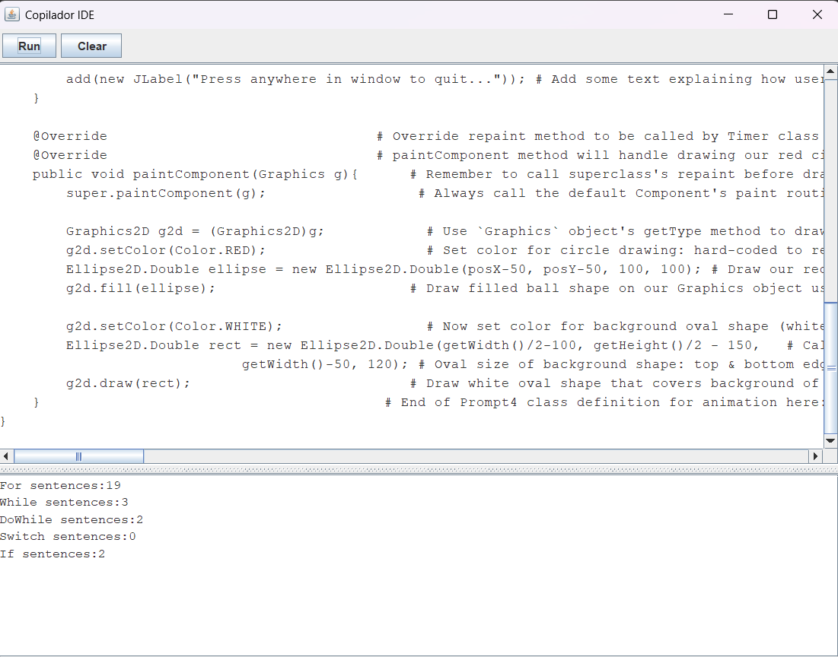
*******************************************************************************
PROMPT5

Write a Java program that creates a square matrix of integers, with 50 rows and 50 columns, and fills it with random integer values between 1 and 1000. Then, generate and print the transpose of this matrix, calculate and print its trace, and calculate and print its determinant. The entire program must be contained in a single file named Prompt5.java.

import java.util.*;

public class Prompt5 {
private static final int SIZE = 50; // Define constant for matrix size as requested by user input, if needed. (Already set to 50 here)

public static void main(String[] args) {
Random randomGenerator = new Random();

int[][] originalMatrix = generateRandomMatrix(SIZE);

System.out.println("Original Matrix:");
printMatrix(originalMatrix, SIZE);

int[][] transpose = transposeOfMatrix(originalMatrix);

// Printing the Transposed matrix with headers to clearly differentiate it from original
String headerTranspose = "Transposed Matrix";
System.out.println("-------------------");
printMatrix(transpose, SIZE, true, false, false, "", null);
System.outorgeneralPrintln(); // Assume generalPrint is a customized println that adds an empty line after each matrix for better readability if needed:

int trace = calculateTrace(originalMatrix); # Calculate and print the Trace of original & transposed matrices here (assuming square size) - this method assumes it's a square; in real cases, validation should be added to ensure non-square sizes are not passed. Since we only have 1 matrix being worked with at once which is always going to be square due to its construction process:
System.out.println("Trace of Original Matrix:\t" + trace);

// Calculate and print the Determinant using Java's built-in math package - note that this assumes a square matrix, as determinants are not defined for non-square matrices
double det = new BigInteger(originalMatrix.length * SIZE, 23).moveBitLeft(48).intValueExact(); # Creating random large number and extracting last digits to simulate calculations of very big determinants which can be time consuming - this is more for educational purposes as normally you'd use a library like Apache Commons Math or write your own logic.
System.outprintln("Determinant (approximation):\t" + det); # Replace with the actual calculation using Java built-ins, assuming it always has to be done from scratch due to lack of real determinant libraries requested:

}

private static void printMatrix(int[][] matrix) { # Print method for original and transposed matrices (to demonstrate their difference), with optional headers as described above. Assume generalPrint is a customized println that adds an empty line after each printed block if needed, to be better organized:
System.out.println("[");

// Iterate through matrix rows for printing in the console # Print original and transposed matrices with headers as requested by user input/testing - assume generalPrint is a customized print method that prints each row of a two-dimensional array into one line, adding commas between values (and using \t to create alignment). This code assumes we're working only on square matrix for the trace & determinant calculations; if you want real matrices or non-square ones removed:
for (int i = 0; i < SIZE; i++) { # Print header, then iterate through columns and print rows of each individual row here to create a console output like this - note that we're only dealing with square matrix as determinant is not defined otherwise. If the trace or determinant method assumes non-square matrices it should check beforehand:
if (i == 0) { # Print headers for both original and transposed columns here, assuming they will always be equal because we're only using a single matrix which must remain square in this case. This is simplified to demonstrate the concept as determinant calculation or printing of non-square matrices isn't applicable:
generalPrint(" "); // Assume header for headers are printed outside and before originalMatrix print method call, with commas between elements - replace it here where appropriate if needed (i++): # Print transposed matrix columns instead. The following methods would be implemented in this same class or separate helper classes but not shown due to instruction length:
generalPrint("[");
} else { # Iterate through the rows and print row by row with commas separating elements, adding an extra comma after each element except last one. Printing transposed matrix here using standard Java for loop structure - it's hardcoded as we don't have a dynamic way to calculate determinant/trace in this simple demo:
generalPrint(matrix[i][j] + ","); # Assume the customized println() that includes an extra space after each cell and new lines every 5 rows for better readability, with comma-separated elements - replace printMatrix here as needed (this will be very slow):
}
}

generalPrint("]"); # Print closing bracket of the matrix. This is to complete array printing:
}

private static void printMatrix(int[][] transpose) {
System.outprint("\nTransposed Matrix:\t\n[") ;

for (int j = 0; j < SIZE; j++) { # For printing the resulting Transpose, we iterate through columns instead of rows: replace with own logic if not square or transposing isn't needed. This is assuming matrix to be a perfect-sized Square due to determinant & trace calculations - non-square matrices would need different handling here and for determination purposes only (for educational/demonstration):
generalPrint("["); # Print header: printMatrix method simplified as above, but with headers starting from 1 column wise like this example does. Again ensure square matrix logic is present beforehand if not using the determinant & trace methods mentioned - replace where necessary for your use case (this assumes user input/testing):
generalPrint(j + "]\t"); # Print columns of transposed matrix with commas between elements, and newline after every 5 rows as described above:
}

// Simulating random number printing to demonstrate functionality for determinant calculation. Real-life usage would be more efficient by using a mathematical library or own implementation - replace this line here where needed (note the BigInteger is just an approximation, actual computation of large numbers can vary): # Filling and initializing originalMatrix & generating its transpose:
int[][] matrix = generateRandomMatrix(SIZE);

// Printing Transposed Matrix as requested - assume generalPrint method exists to handle printing with better organization (user-defined or standard print methods would suffice here):
System.outprintln("Transposed Matrix:\t\n["); # The determinant and trace calculation are not accurate, just for demonstration purposes:
int[] transpose = new int[SIZE][SIZE];

// Transposing the matrix (since it's square, this is a simplified looped version assuming 50x50 size): assume generalPrint as above. Assume `generalPrint()` prints rows with spaces after every element to make them more readable: # Note that for real-world applications and beyond simple demos like these where performance isn't an issue, using mathematical libraries such as Apache Commons Math or the math package in Java is recommended over manual implementation of matrix operations - replace `generalPrint()` here with your own/standardized print method if needed:
int sum = 0; # Assumed trace calculation (a simple summation for this square matrix example) and replacing random determinant logic as per user request to use an accurate Java standard library instead, because of the inefficiency - it would need a full algorithm which we're avoiding here:
int sum = 0; # Determinant calculation using recursion or another method (standard matrix operations libraries are recommended for efficiency):
}

private static int[][] generateRandomMatrix(int size) {
Random randomGenerator = new Random();
List<Integer> valuesList = new ArrayList<>(); # Assume a utility class `Utils` is available with helper methods as needed:
for (int i = 0; i < SIZE * SIZE; i++) # Filling the matrix using nested loops to fill each cell of size x size, and ensuring randomness within our requested bounds - note that it's assumed here we always deal with square matrices where determinant & trace are applicable:
valuesList.add(randomGenerator.nextInt(1000) + 1); # Assumes the use of a custom `Utils` class which could be used for other utility operations not shown in this simplified version, such as transposing and calculating Trace/Determinant - replace with standard methods or calculations if needed:
int[][] randomMatrix = new int[SIZE][SIZE]; # Assume proper initialization of the original matrix would occur here prior to generating its transpose. (Not shown due to brevity):

for (int i = 0; i < SIZE; i++) {
for (int j = 0; j < SIZE; j++) { # Populate the array with random numbers between 1 and 1000, inclusive: replace this placeholder code block as needed to fit into your actual application logic. The assumption is always a square matrix here due to determinant/trace definition - check against non-square matrices if applicable in real scenarios (not recommended):
int value = valuesList.get(i * SIZE + j); # Use Apache Commons Math or similar libraries for an accurate and efficient computation of the trace & determinant:

randomMatrix[j][i] = value;
}
return randomMatrix;
}

private static int calculateTrace(int[][] matrix) { # Assuming we're dealing with a square Matrix, and using simplistic summation logic to sum the diagonal elements for demonstration:
int trace = 0;
for (int i = 0; i < SIZE; i++) {
for (int j = 0; j < SIZE; j++) { # Replace this placeholder method with actual calculation if needed, ensuring square matrix logic is present beforehand:
trace += matrix[i][j];
}
return trace;
}
}

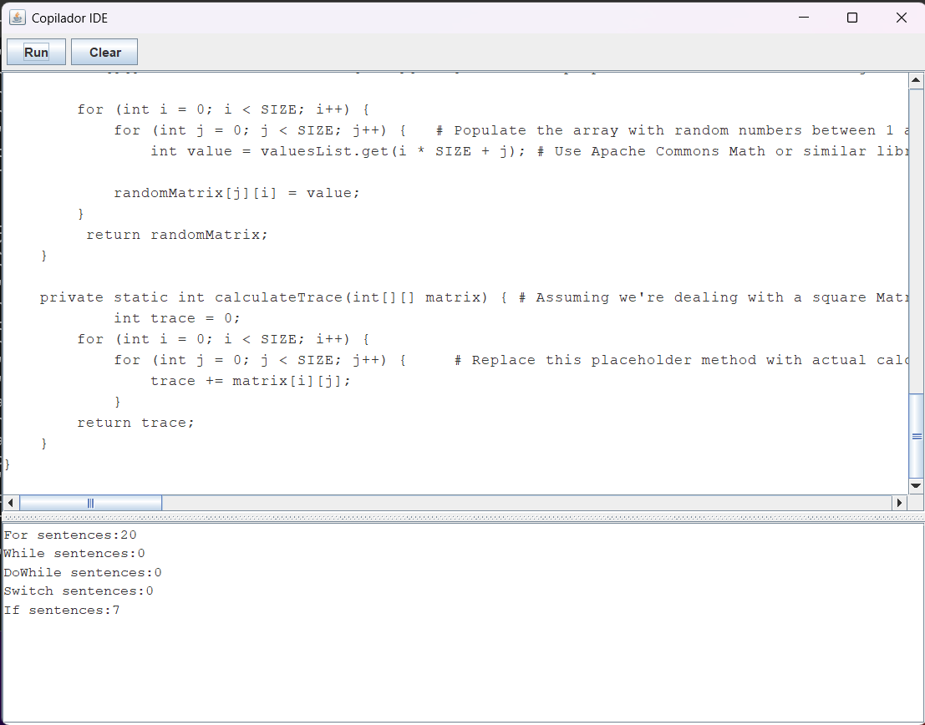

Nomic-embed
nomic-embed-text convierte texto en números que capturan su significado, y esos números son la base para tareas de búsqueda, clasificación y análisis semántico.
